**Kolt 45 Mastery Challenge**

Kolt 45 Mastery Challenge is an app that allows you to battle your friends for ultimate bragging rights. Choose a champion to race to see who can get to the point limit the fastest. Find a summoner to challenge, send them a challenge and when they accept, you’re off to the fight. Achievements are awarded to the victor.

**Landing Page**

You’ll land on the site and be immediately fired up by everyone’s least favorite champ. Log in and begin a challenge

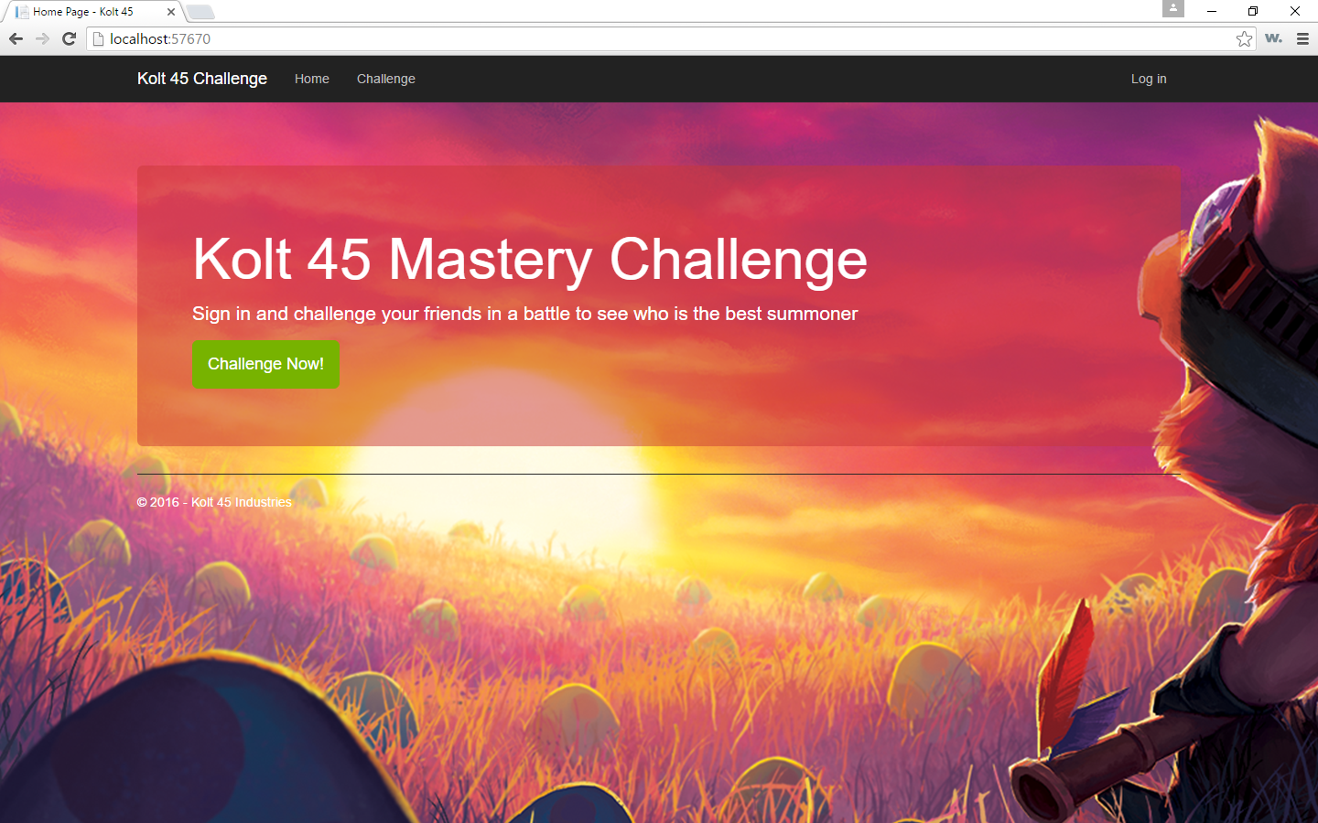

**Login Page**

Login if you have an existing account or create a new one if you don’t have one

Logins can be tied to one summoner. If a summoner is already linked to an account, it will not be abllow to be created

